Step1: First we need go Jenkins dashboard then we need to create new job or item with maven project

Step2: go to the job configure then we need give Git hub URL

Step3: Then goto Jenkins Dashboard and click the manage Jenkins

Step4: search for s3 plugin and install

Step5: Go to Jenkins dashboard and go to manage Jenkins and click the configure system and add the **Amazon S3 profiles**

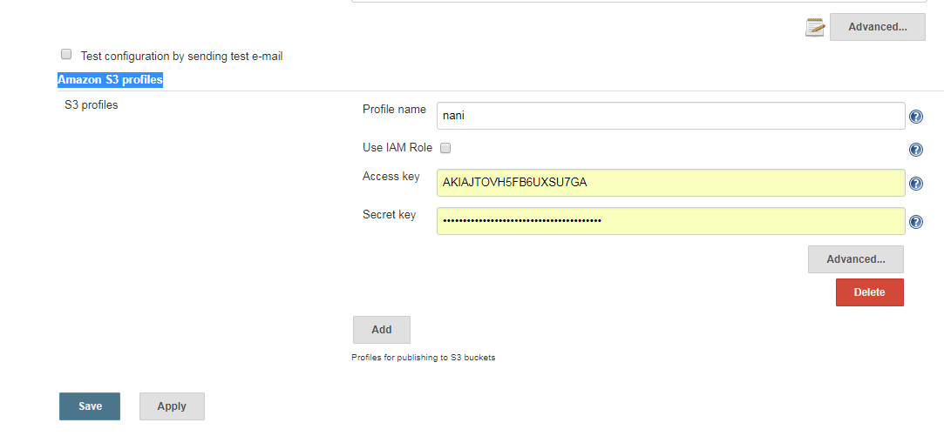

Step 6: add access key and secrete key these two are available in amazon s3 bucket then save the console

Step7:then we need go to job configure and go to **Post-build Actions and** select the publish artifacts to s3 buckets and give the s3 profile give any name like your name and next source give **\*\*/*.war for** default war files

Destination bucket : bucket name give the file name

Bucket region :given your s3 region

|  |
| --- |
| Manage artifacts (select)  Server side encryption (select) |
|  |

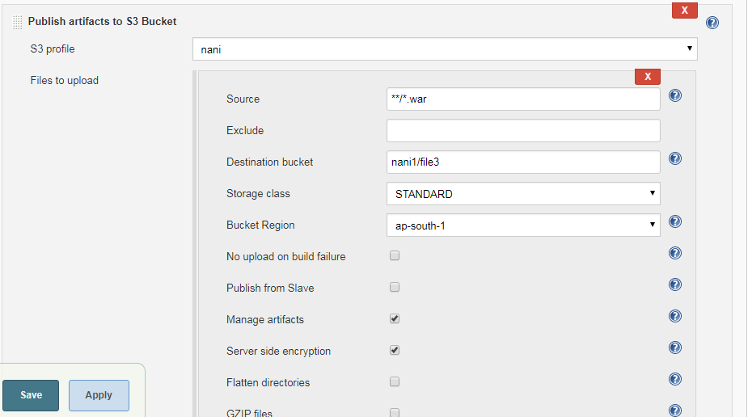

Then save .

Step *: then build the job